**Issues faced and actions taken**

**What is a middle wear**

**Middle wear is used in our system**

**Justify why we use Laravel as middlewear**

**Mobile app screen shots**

Main activity is where the code responsible for the temporary splash screen is visible as you access the mobile application

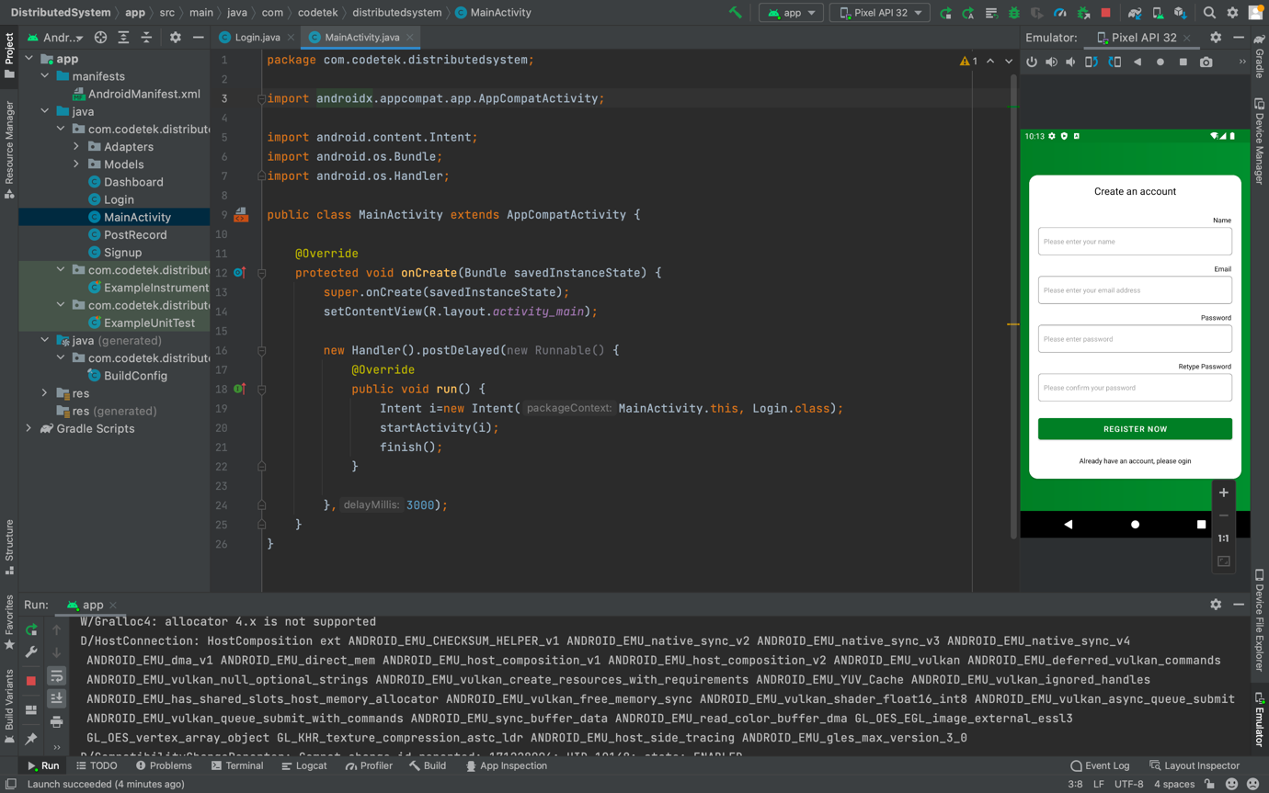

Login

Login screen code is present in this code view as shown with the running interface in the right side of the screen shot

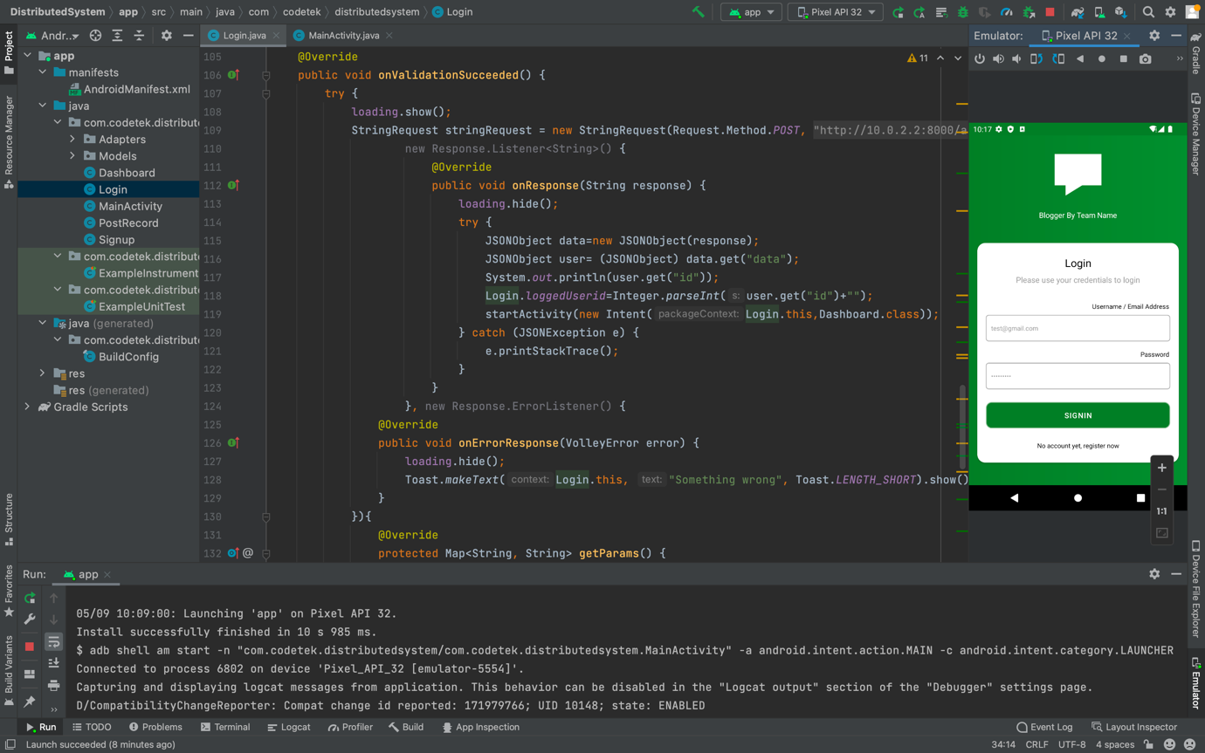

Dashboard

This shows the code responsible for the post page in the mobile view where the user can view the posts

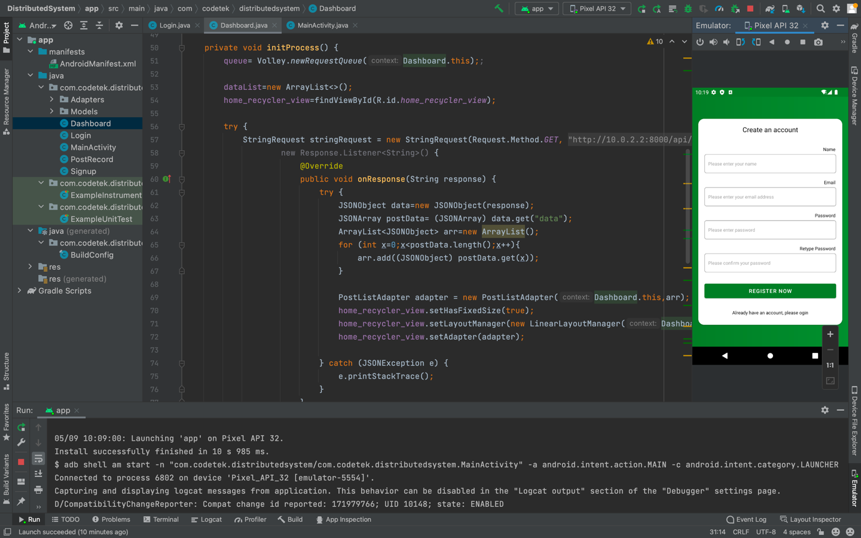

Post record

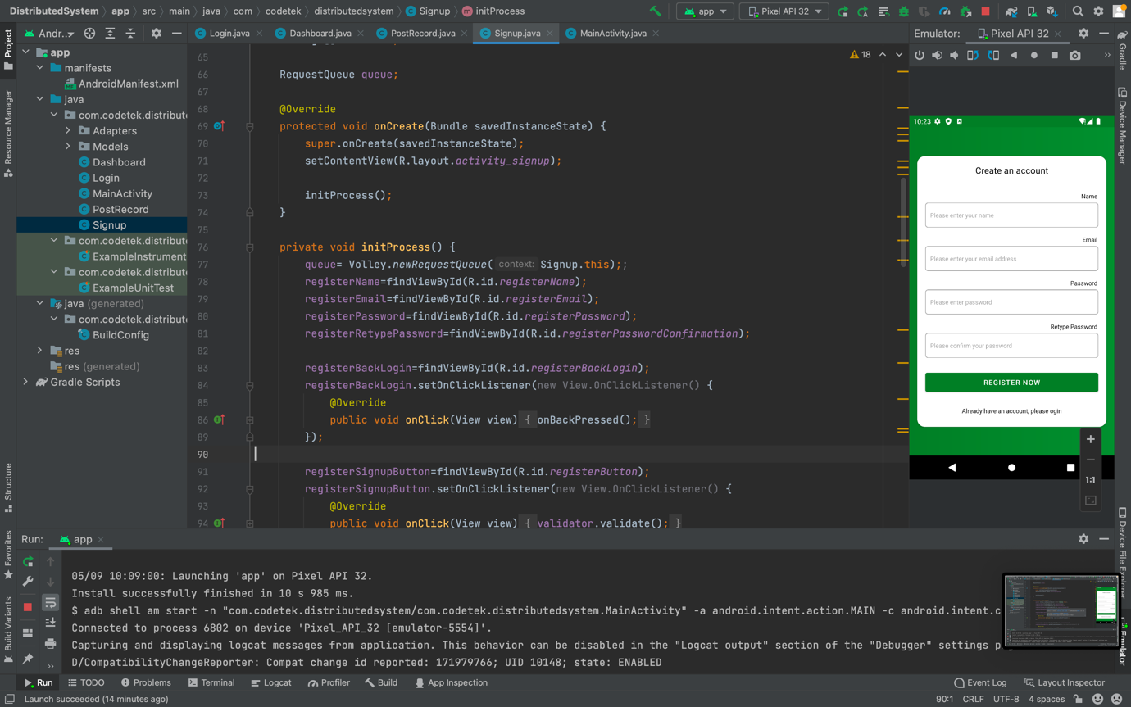

Signup screen

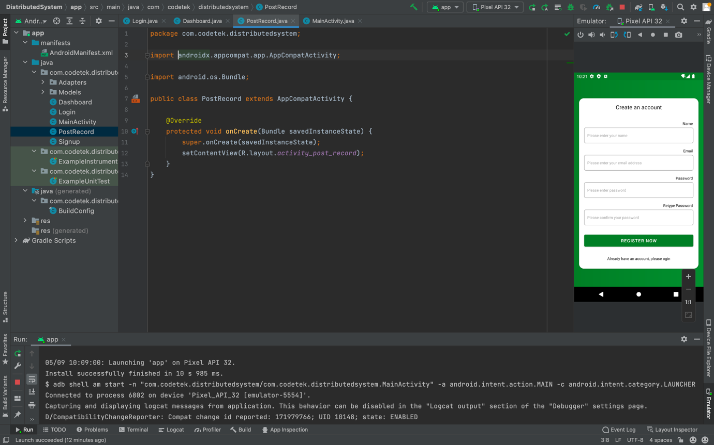

Models folder

The model folder is responsible for storing user data and serialization of that data

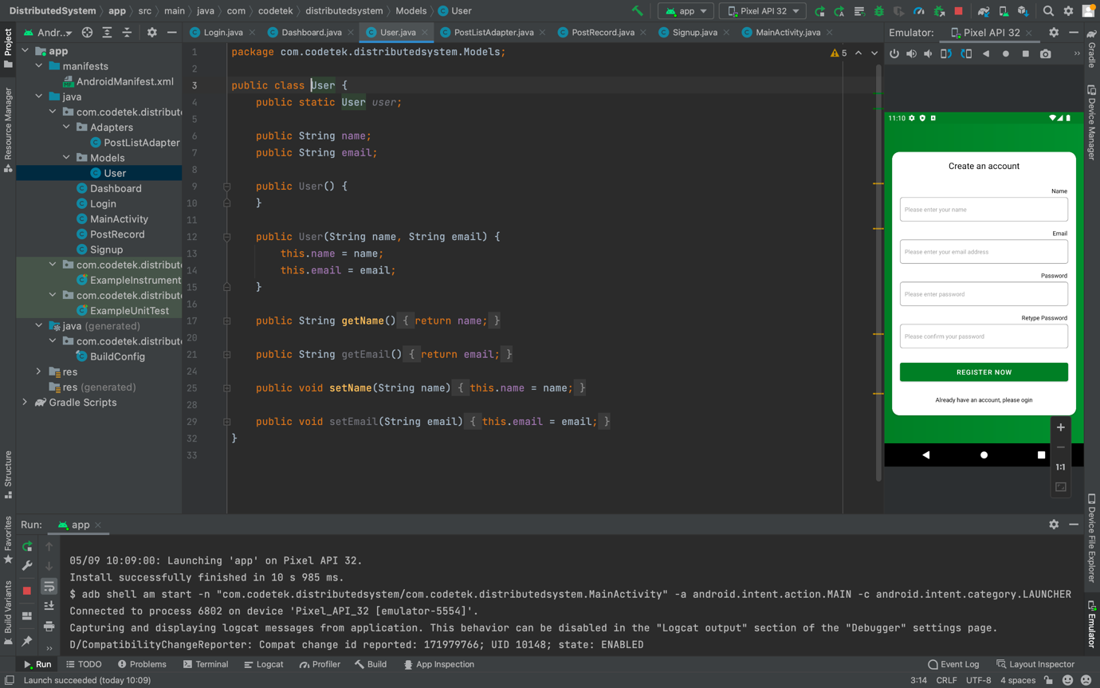

Post list adapter folder

This block of code is responsible for the way on which the posts are displayed for the users of the application by accordingly seggrigating the title of post , description and uploaded images etc

